LAB ASSIGNMENT-3.4
2303A51295BATCH-10
TASK-1:

PROMPT:

Generate a python function to print first N Fibonacci numbers

CODE:
def fibonacci(n):
a, b = 0, 1
for i in range(n):
print(a, end=" ")
a, b = b, a + b

fibonacci(7)
OUTPUT:
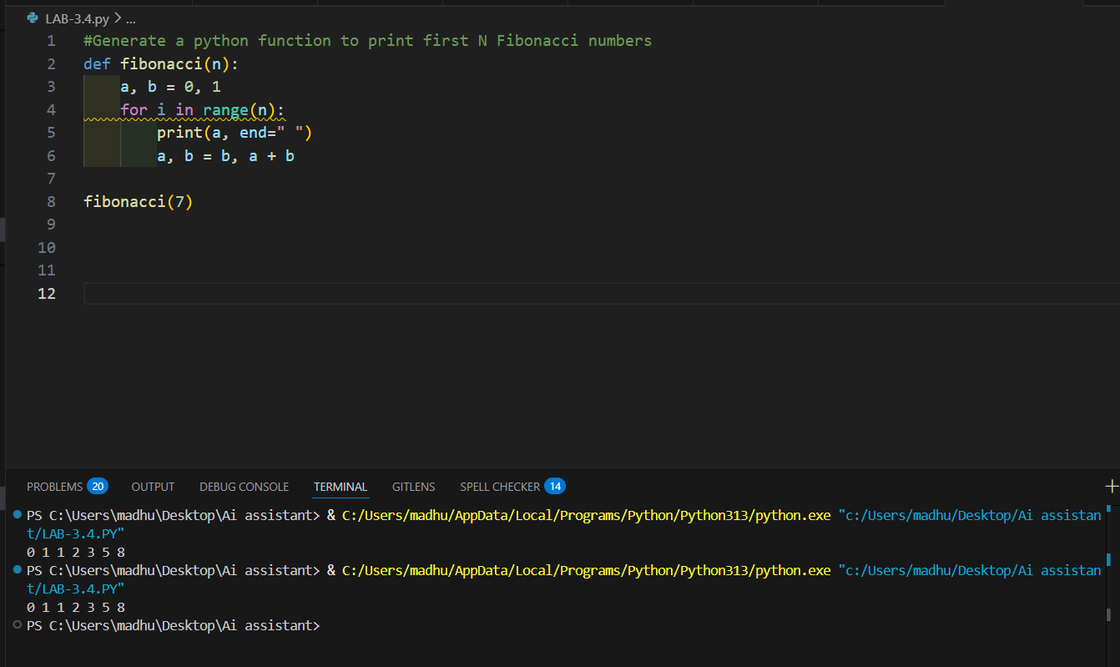
EXPLANATION:
• The function generates Fibonacci numbers using two variables.
• A loop runs N times and prints numbers one by one.

TASK-2
PROMPT:

# Write a python function to reverse a list

# Example: reverse_list([1,2,3]) should return [3,2,1]

CODE:
def reverse_list(lst):
return lst[::-1]
print(reverse_list([1,2,3]))
OUTPUT:
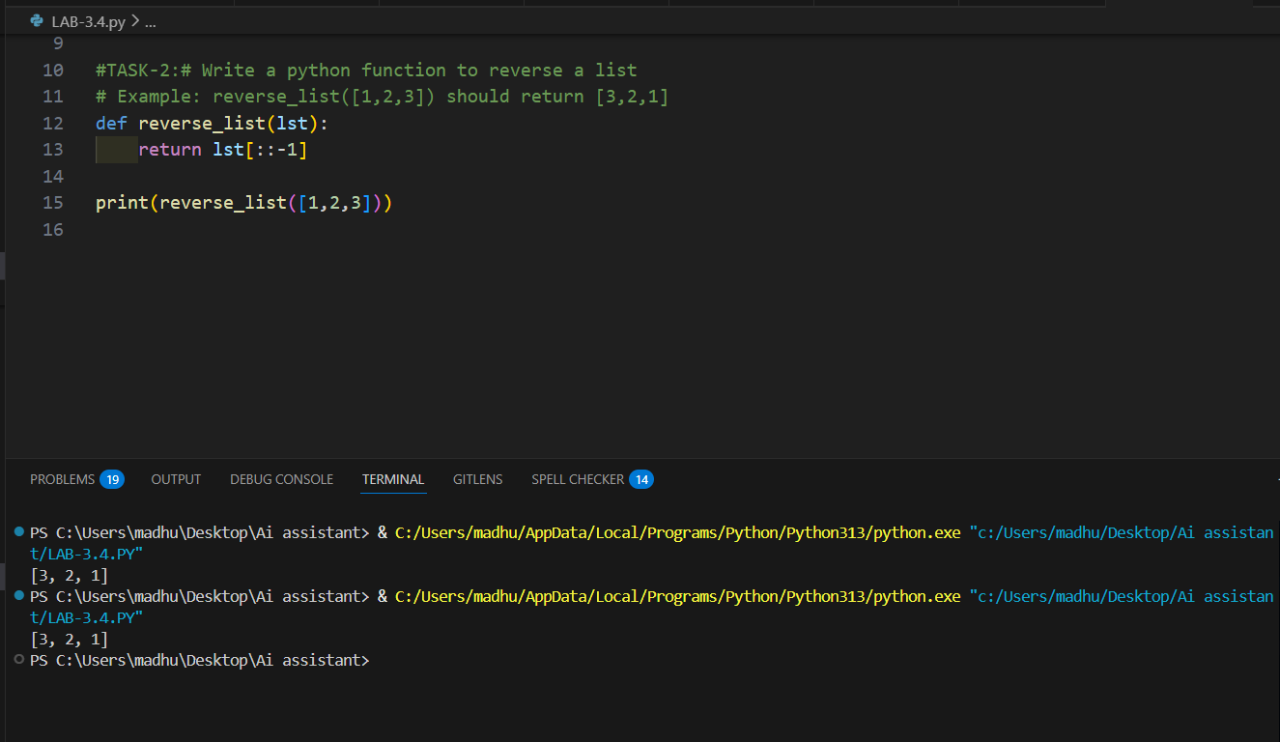

EXPLANATION:
• The function reverses the given list.
• It uses slicing method to change order of elements.
• The output list is returned in reverse format.

TASK-3:

PROMPT:

Write a function is_valid() that returns True and The string start with a capital letter and ends with a period. Ask the user about their past behavior (this is their history)

CODE:
def is_valid(s)
return s[0].isupper() and s.endswith('.')
print(is_valid("Hello."))
print(is_valid("hello."))
print(is_valid("Hello"))
OUTPUT:
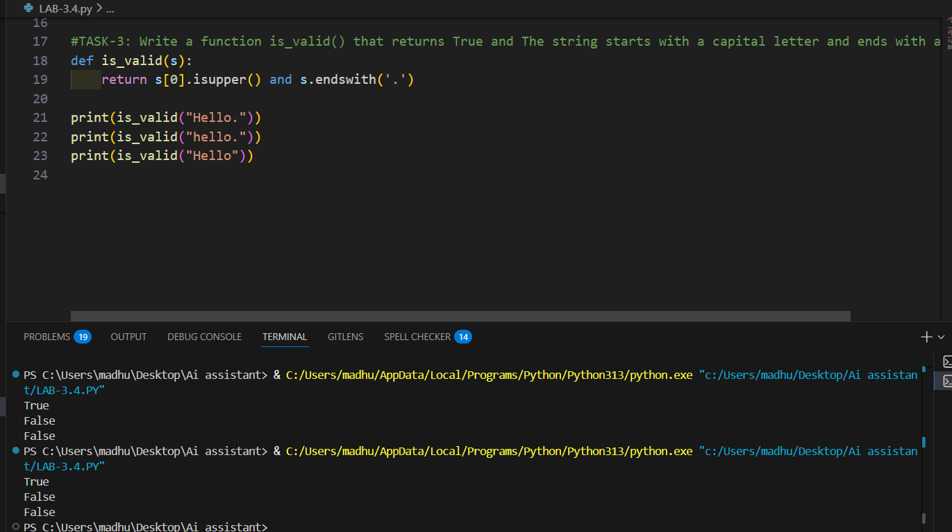

EXPLANATION:
- The function checks whether the first letter is capital.
- It also checks whether the string ends with a period.
- Both conditions must be true to return True.

TASK-4:

PROMPT:

Write a python function to validate an email address

CODE:
import re

def validate_email(email):
pattern = r"^[a-zA-Z0-9_.+-]+@[a-zA-Z0-9-]+\.[a-zA-Z0-9-.]+$"
if re.match(pattern, email):
return True
else:
return False

email = input("Enter email address: ")

if validate_email(email):
print("Valid Email")
else:
print("Invalid Email")

OUTPUT:
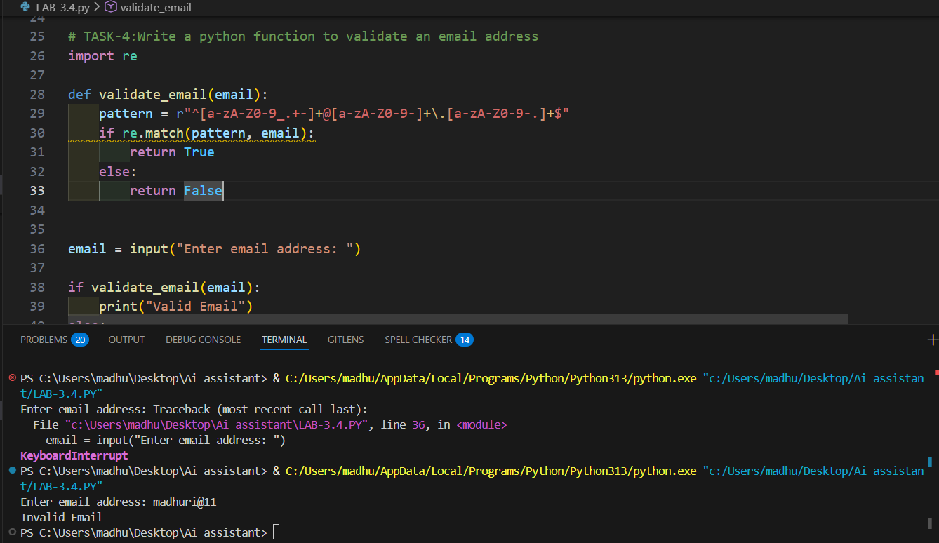
EXPLANATION:
• The function checks if email contains “@” symbol.
• It also checks if email contains a dot (.).
• This is a simple and basic validation method.
TASK-5:

PROMPT:

Write a function to return sum of digits of a number

CODE:
def sum_of_digits(n):
total = 0
while n > 0:
total += n % 10
n = n // 10
return total

print(sum_of_digits(123))
OUTPUT:
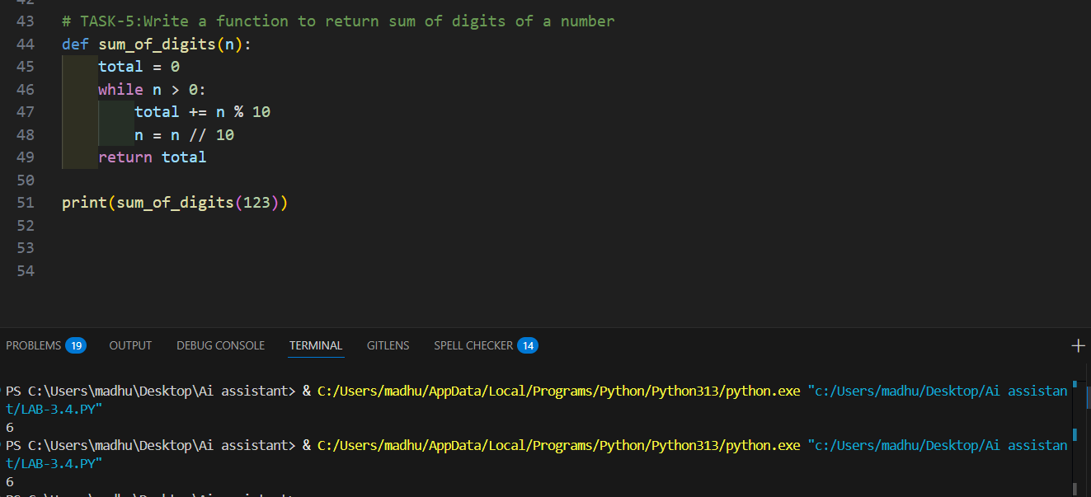

EXPLANATION:
- The function extracts digits using loop.
- Each digit is added to total sum.
- Finally the sum of digits is returned.

